EXPEREIMENT 3

Create a simple cloud software application for Car Booking Reservation System using any Cloud Service Provider to demonstrate SaaS include the necessary fields such as search for cabs, from, to, rental , out station, Package type, hours/Days etc.

1. create rider application form

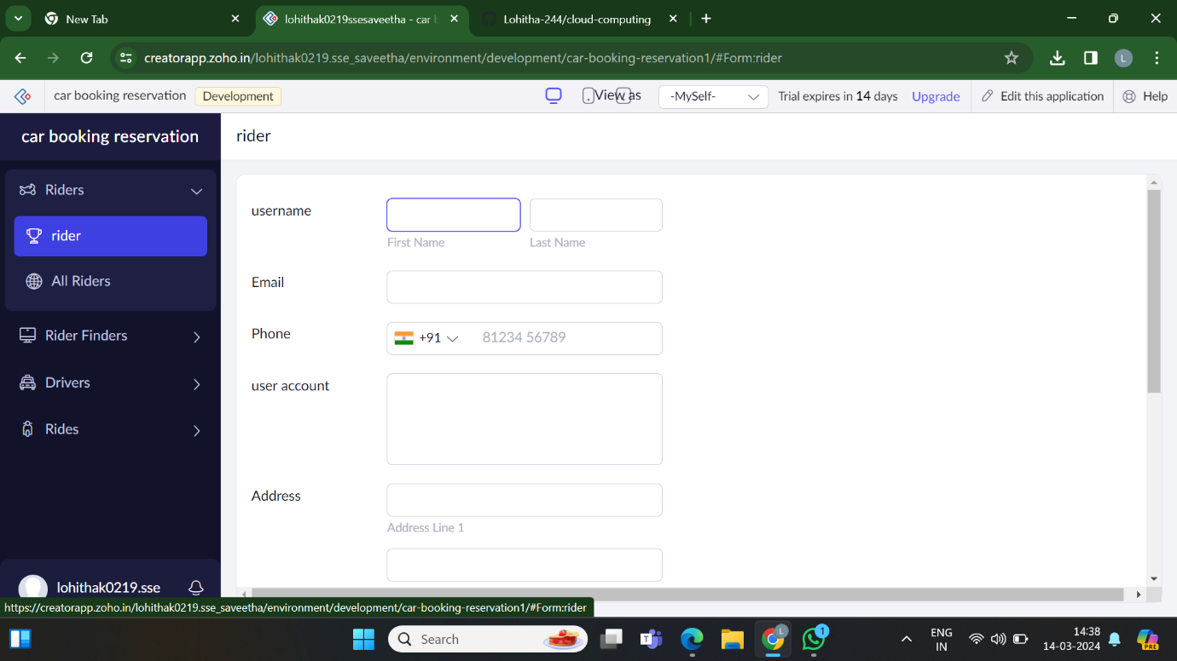

2.create driver application form

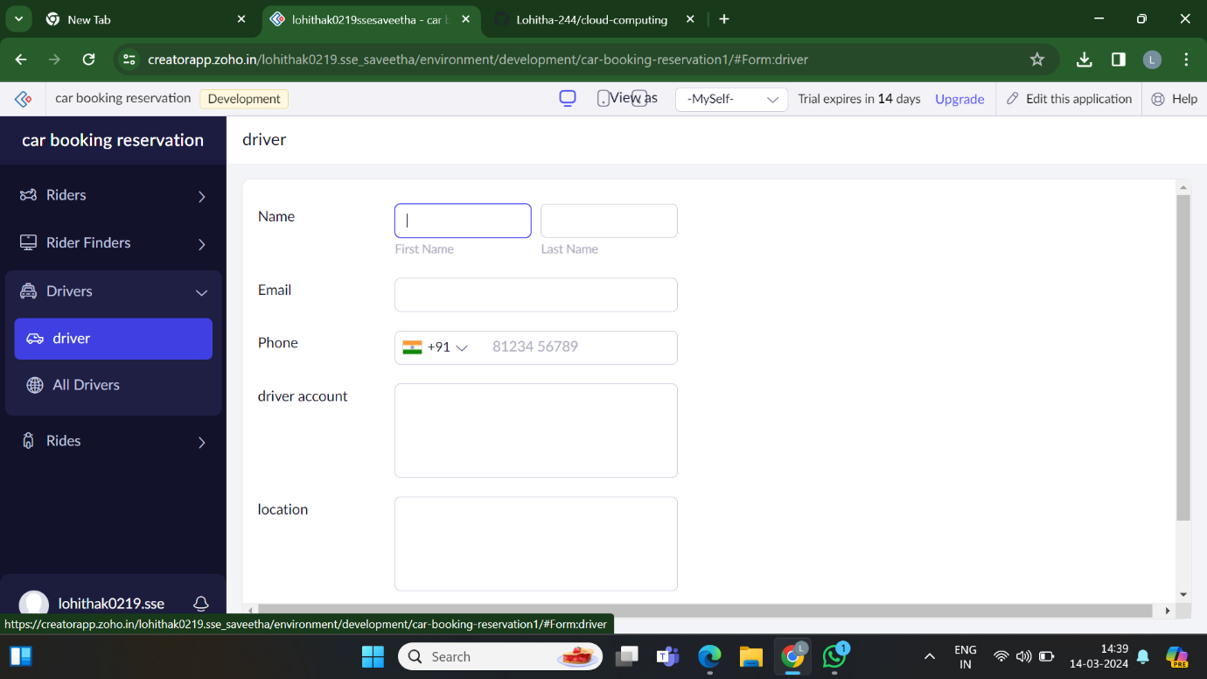

3.create rider finder application form

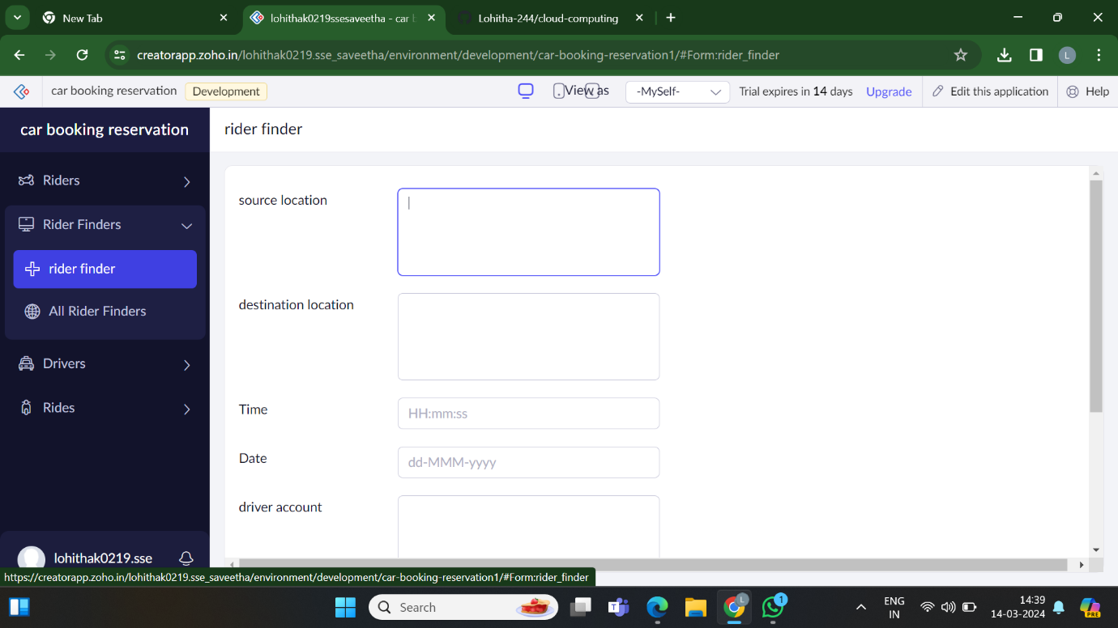

4.create ride application form

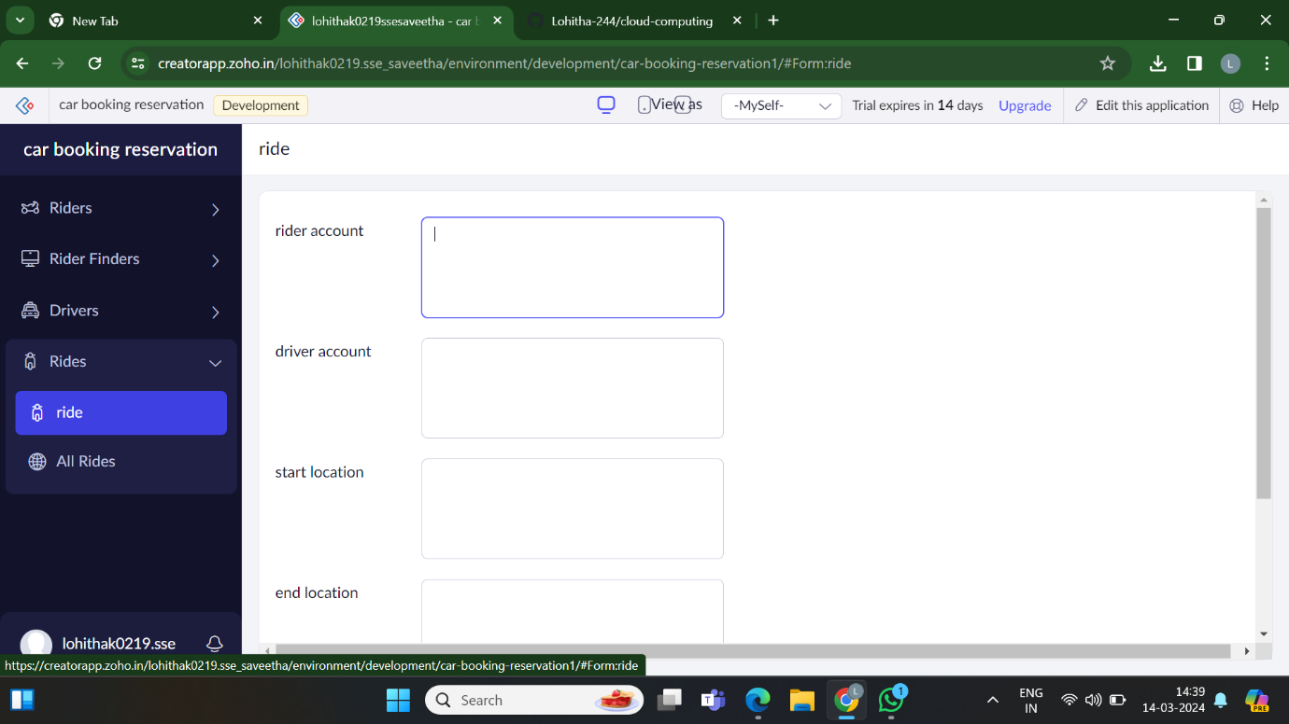

5.showes the required user (rider)details

